The significance of cars in our society and their effects.

Prepared for

Mwebaze Ernest

Prepared by

Ssempala Raymond

Table of contents

Abstract 5

**1. Chapter 1** 6

1.0 Introduction 6

1.01 Significancy of the Study 6

1.02 Statement of th Problem 6

1.1 Fuel and Propulsion Technologies 6

1.2 User Interface 6

1.3 Weight, Seating and Body Style 7

**Chapter 2** 8

2.1 Findings 8

2.1.0 Graph 8

2.1.1 Digrams 9

2.1.2 Conclusion 9

2.1.3 Bibliography 11

Abstract/Executive Summary

The project is about cars, the different car types and examples which include land rovers, range rovers, spacious, Mercedes Benz etc.

The main objective was to look at the significances of cars, the various types. We will also look at the various hazard, challenges and effects caused and faced by cars.

1. Chapter 1

This chapter highlights the introduction of the project, significance of the study, statement of the problem, and the objectives, the user requirements, the functional and non-functional requirements, the software and the hardware requirements of the application to the real world.

1. Introduction

Cars are a very important aspect in our lives today. Cars originate from the term vehicles which symbolizes a lot of mobile machines that transport people or cargo. According to my research, basically I took a case study in Uganda where different people have different views about cars. There are a lot of merits and demerits about cars but they all depend on the different views people have.

On the other hand, there over 1billion cars in the world and a rough estimate of 3 million cars in Uganda according to people. Different cars cost different prices and different people drive different cars for examples spacious, Subaru, range rovers, Mercedes Benz, mini cooper, Noah, wish etc.

According to the research, there are problems faced by people as a result of the cars like accidents, unstable fuel consumption rates, expenses incurred during maintenances and many other problems caused to the environment like noise pollution and air pollution.

1.0.1 Significance of the Study

Cars have a great impact on the population of the world to date. Since the 20th century, the role of the car has become highly important. It is used thought the world and it is the most popular mode of transportation. In developing countries like Uganda, the effects of a car on society are not as visible as in developed countries, however they are significant.

Though cars are important, they also have a negative effects like pollution either noise or air to the environment due to the emission of fumes. Accidents have become rampant due to the different causes like reckless driving, driving under influence, over speeding and many others.

1.0.2 Statement of the Problem

This project will address the different challenges being faced by people which include accidents, costs, maintenances etc. and cars and more importantly the difficulties that arose as I was collecting the information.

In this section we are going to also consider the different hazards cars impact on the environment. they cause pollution either noise or air to the environment due to the emission of fumes. Accidents have become rampant due to the different causes like reckless driving, driving under influence, over speeding and many others.

1.1 Fuel and Propulsion technologies

Most cars used today are propelled by an internal combustion engine, fueled by deflagration of gasoline or diesel. Both fuels are known to cause air pollution. Efforts to improve existing technologies include the development of hybrid cars, plug-in electric cars and hydrogen cars. Oil consumption in the 20th and 21st centuries has been abundantly pushed by car growth.

1.2 User interface

Cars are equipped with controls used for driving, passenger comfort and safety. Controls also include steering wheel, pedals for operating the brakes and control the car’s speed. And also cars are either manual transmission or automatic transmission.

1.3 Weight, Seating and body style

The average weight of the car is around 1,818kg (4,009 lb.) according to the estimation of different individuals. Most cars are designed to carry multiple occupants, often with four to six seats. Normally two passenger in front and three in the back.

2. Chapter 2

This chapter highlights the findings, diagrams, conclusion and bibliography.

* 1. Findings

2.1.0 Graph

According to the world sales archives, different brands of cars have different percentages in the market.

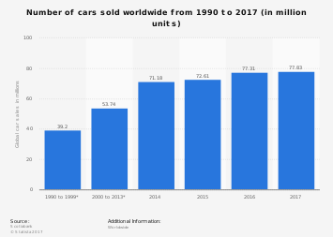

2.1.1 Table

In Uganda, the rough estimate in percentage of sales of cars is as below:

|  |  |  |  |
| --- | --- | --- | --- |
| Rank | Brand | Sales | Percentage |
| 1 | Toyota | 2,428,571 | 84.92% |
| 2 | Mercedes-Benz | 234,546 | 8.20% |
| 3 | Honda | 95,355 | 3.34% |
| 4 | Nissan | 67,454 | 2.35% |
| 5 | Kia | 21,343 | 0.74% |
| 6 | BMW | 12,454 | 0.43% |
| 7 | Range Rover | 10,345 | 0.36% |

2.1.1 Diagrams

Using the Open Data Kit Collect, below are some of the samples screen shots.

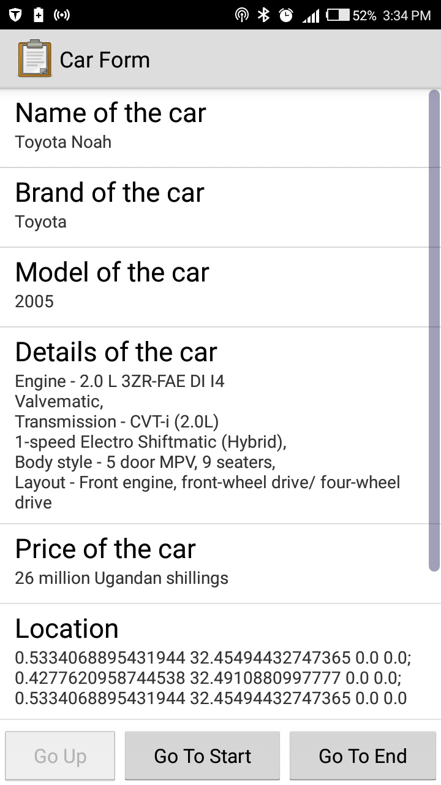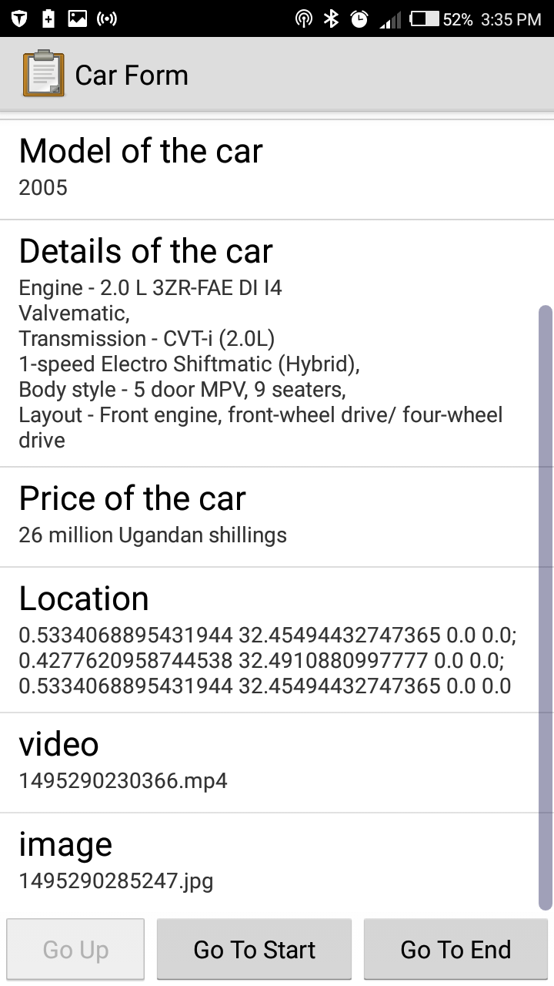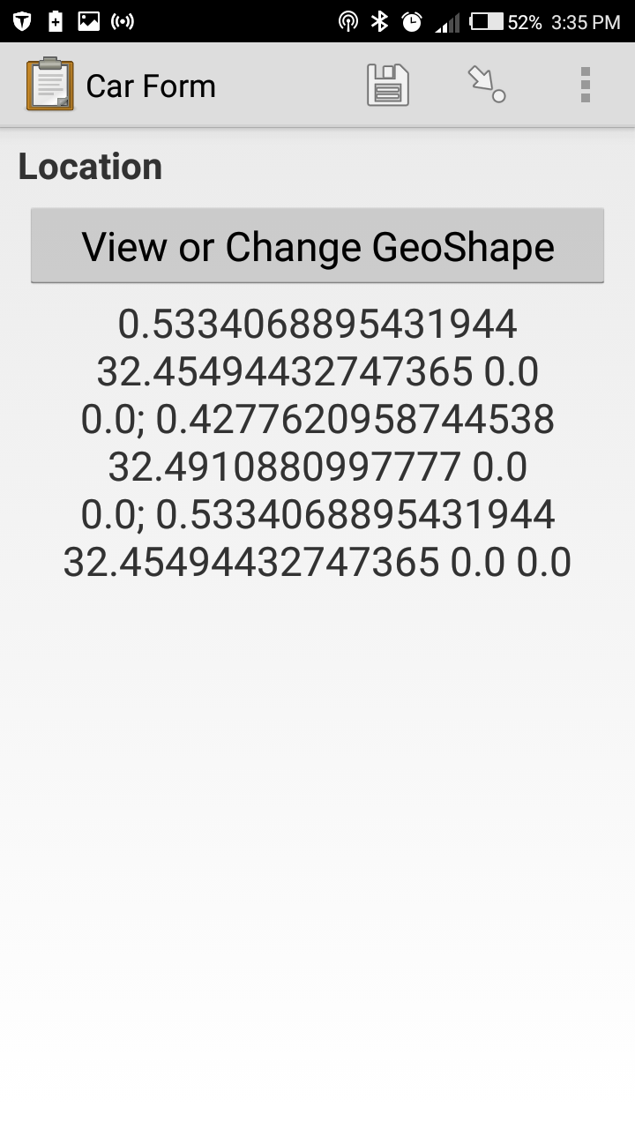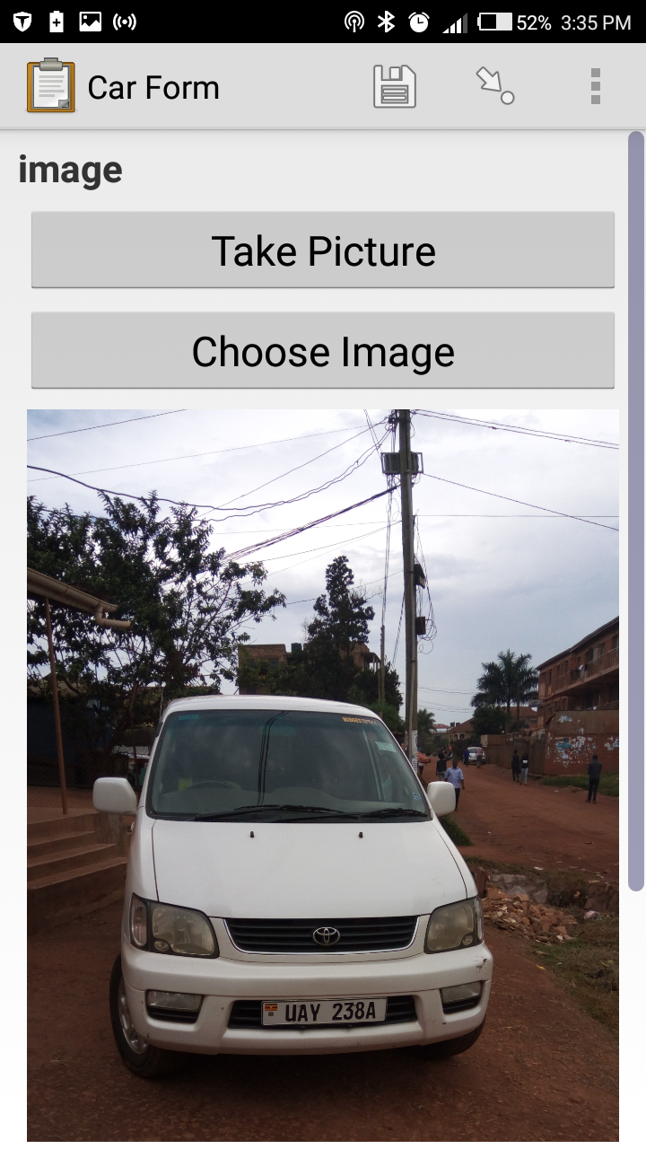

* + 1. Conclusion

On the basis of the findings, cars that are being sold increases each year. This implies that there is more production/ manufacture of cars due to the increasing population in the world. Basing on the case study of Uganda, Toyota is the most sold brand have an estimated percentage of 84.92%. Very few people buy a Range rover brand due to its price. Due to the fluctuating oil prices in Uganda, this has led to the decreased selling of cars. Though the problem of fuel is worldwide because of its other negative effects like pollution. This has led to the development of electric cars which are rechargeable, hydrogen powered cars have also been developed.

Development of self-driving cars have also been manufactured to cab down problems like accidents were also more sophisticated technology is being used in cars.

2.1.3 Bibliography

1 Stein, Ralph (1967). *The Automobile Book*. Paul Hamlyn.

2 ["motor car, n."](http://www.oed.com/view/Entry/122742#eid35698343). *OED Online*. Oxford University Press. September 2014. Retrieved 2014-09-29.

3 ["auto-, comb. form2"](http://www.oed.com/view/Entry/13368?redirectedFrom=autocar#eid32737946). *OED Online*. Oxford University Press. September 2014. Retrieved 2014-09-29.